**MEETING REPORT 4**

**Team Name:**  Furniture_Management_System (Team 14)

**Date of Meeting:**  19/04/2025

**Start Time:** 10:40  **End Time:** 12:30 **Meeting Location:**  Google Meet

**Moderator:** Ester Shumeli **Recorder: -**

**Other Members Present: Adi Salaj, Lenore Kalemasi, Gerin Roko, Lea Lila, Vanesa Erindi**

**Members Absent:** None

**Topics Discussed:** Possible improvements, State Diagrams, Class Diagram, ERD

**Decisions Made:**  
The team discussed three main modeling tasks: State Diagrams, Class Diagram, and ERD.. Each member was tasked with designing state diagrams to represent the dynamic behavior of specific system components. Ester was also assigned to develop the class diagram to represent the structure and relationships of system classes. Adi was responsible for creating the ERD to map out the database schema. The team agreed to follow a consistent visual style and notation for all diagrams and to review each model collaboratively in the next meeting to ensure alignment and completeness.

**-Tasks Assigned:**

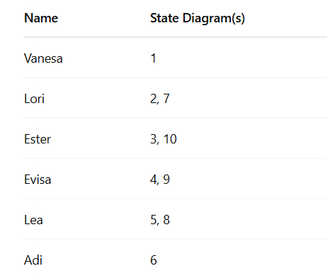

**Class Diagram**: Ester; **ERD:** Adi

**-Time, Place, and Agenda for Next Meeting:** TBD